Comandos com Select

1. Selecione nome e dataNascimento dos alunos que começam com a letra "X".

[SELECT](http://localhost/phpmyadmin/url.php?url=https://dev.mysql.com/doc/refman/5.5/en/select.html) nome, datanascimento FROM `cliente` WHERE nome [LIKE](http://localhost/phpmyadmin/url.php?url=https://dev.mysql.com/doc/refman/5.5/en/string-comparison-functions.html#operator_like) 'g%'

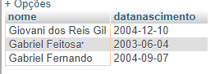

2)Selecione nome, e-mail e dataNascimento dos alunos que nasceram no mês x;

[SELECT](http://localhost/phpmyadmin/url.php?url=https://dev.mysql.com/doc/refman/5.5/en/select.html) nome, email, datanascimento FROM cliente WHERE month(datanascimento)='12'

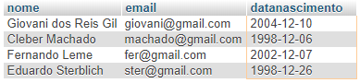

3)Selecione nome e telefone dos alunos que nasceram no ano x;

[SELECT](http://localhost/phpmyadmin/url.php?url=https://dev.mysql.com/doc/refman/5.5/en/select.html) nome, email, datanascimento FROM cliente WHERE [year](http://localhost/phpmyadmin/url.php?url=https://dev.mysql.com/doc/refman/5.5/en/date-and-time-types.html)(datanascimento)='1998'



4) Ordene os alunos em ordem decrescente por Turma;

[SELECT](http://localhost/phpmyadmin/url.php?url=https://dev.mysql.com/doc/refman/5.5/en/select.html) \* FROM `cliente` ORDER BY turma desc

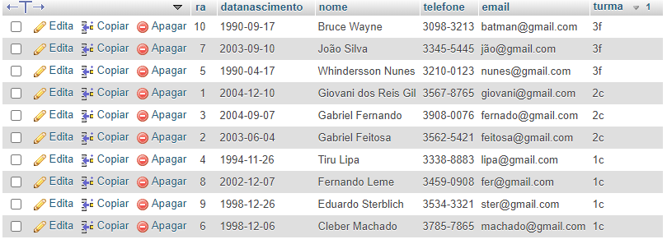

5) Selecione os livros do Gênero "X";

[SELECT](http://localhost/phpmyadmin/url.php?url=https://dev.mysql.com/doc/refman/5.5/en/select.html) titulo, autor, genero from livro where genero ='Infantil'

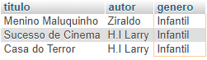

6) Quantos livros tem cadastrados;

[SELECT](http://localhost/phpmyadmin/url.php?url=https://dev.mysql.com/doc/refman/5.5/en/select.html) [COUNT](http://localhost/phpmyadmin/url.php?url=https://dev.mysql.com/doc/refman/5.5/en/group-by-functions.html#function_count)(\*) FROM livro

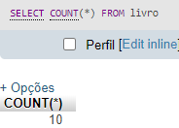

7) Selecione os livros do autor "X";

[SELECT](http://localhost/phpmyadmin/url.php?url=https://dev.mysql.com/doc/refman/5.5/en/select.html) titulo, autor, genero from livro where autor ='Júlio Verne'



8) Selecione os empréstimos que aconteceram no mes "X";

[SELECT](http://localhost/phpmyadmin/url.php?url=https://dev.mysql.com/doc/refman/5.5/en/select.html) data\_emprestimo, data\_devolucao, ra FROM emprestimo\_devolucao WHERE month(data\_emprestimo)='05'

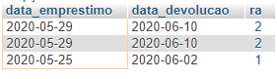

9) Selecione os empréstimos que aconteceram entre os anos "X" e "Y";

[SELECT](http://localhost/phpmyadmin/url.php?url=https://dev.mysql.com/doc/refman/5.5/en/select.html) data\_emprestimo, data\_devolucao, ra FROM emprestimo\_devolucao WHERE data\_emprestimo BETWEEN '2019-01-01' [and](http://localhost/phpmyadmin/url.php?url=https://dev.mysql.com/doc/refman/5.5/en/logical-operators.html#operator_and) '2020-12-31'

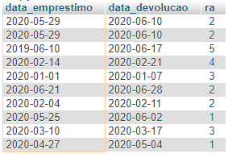

10) Selecione os bibliotecários que são da cidade "X";

[SELECT](http://localhost/phpmyadmin/url.php?url=https://dev.mysql.com/doc/refman/5.5/en/select.html) nome, email, cidade from bibliotecario where cidade ='Mauá'

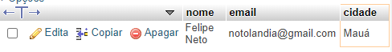

11)Ordene os bibliotecários em ordem alfabética;

[SELECT](http://localhost/phpmyadmin/url.php?url=https://dev.mysql.com/doc/refman/5.5/en/select.html) \* FROM `bibliotecario` ORDER BY nome

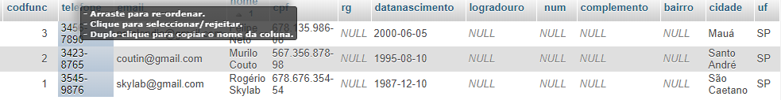

12) Ordene os livros por gênero;

[SELECT](http://localhost/phpmyadmin/url.php?url=https://dev.mysql.com/doc/refman/5.5/en/select.html) \* FROM `livro` ORDER BY genero

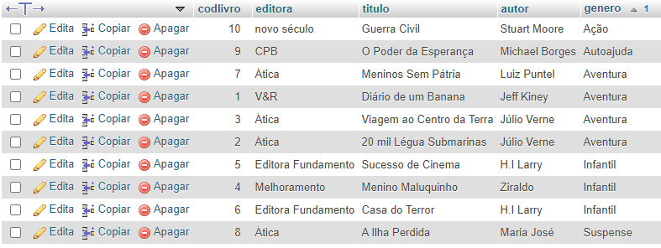

13) Selecione os livros da editora "X";

[SELECT](http://localhost/phpmyadmin/url.php?url=https://dev.mysql.com/doc/refman/5.5/en/select.html) titulo, autor, genero, editora from livro where editora ='Àtica'

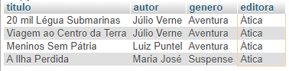

14) Selecione os livros dos autores "X" ou genero "Y" e que tenham menos de "Z" páginas;

[SELECT](http://localhost/phpmyadmin/url.php?url=https://dev.mysql.com/doc/refman/5.5/en/select.html) titulo, autor, genero, paginas from livro WHERE autor="H.I Larry" [or](http://localhost/phpmyadmin/url.php?url=https://dev.mysql.com/doc/refman/5.5/en/logical-operators.html" \l "operator_or" \t "mysql_doc) genero [like](http://localhost/phpmyadmin/url.php?url=https://dev.mysql.com/doc/refman/5.5/en/string-comparison-functions.html" \l "operator_like" \t "mysql_doc)'%infantil' [AND](http://localhost/phpmyadmin/url.php?url=https://dev.mysql.com/doc/refman/5.5/en/logical-operators.html#operator_and) paginas<200

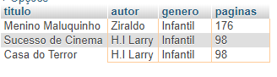

15) Selecione os livros com titulo que começam com a letra "X" e genero "X";

[SELECT](http://localhost/phpmyadmin/url.php?url=https://dev.mysql.com/doc/refman/5.5/en/select.html) titulo, autor, genero, paginas, LetraInicial from livro WHERE LetraInicial="M" [AND](http://localhost/phpmyadmin/url.php?url=https://dev.mysql.com/doc/refman/5.5/en/logical-operators.html#operator_and) genero [like](http://localhost/phpmyadmin/url.php?url=https://dev.mysql.com/doc/refman/5.5/en/string-comparison-functions.html#operator_like)'%infantil'



16) faça a média de paginas de todos os livros;

[SELECT](http://localhost/phpmyadmin/url.php?url=https://dev.mysql.com/doc/refman/5.5/en/select.html) [avg](http://localhost/phpmyadmin/url.php?url=https://dev.mysql.com/doc/refman/5.5/en/group-by-functions.html" \l "function_avg" \t "mysql_doc)(paginas) from livro



17) faça a soma de páginas de todos os livros;

[SELECT](http://localhost/phpmyadmin/url.php?url=https://dev.mysql.com/doc/refman/5.5/en/select.html) [SUM](http://localhost/phpmyadmin/url.php?url=https://dev.mysql.com/doc/refman/5.5/en/group-by-functions.html#function_sum)(paginas) from livro



18) Selecione os livros que tenham entre 4 e 6 exemplares

[SELECT](http://localhost/phpmyadmin/url.php?url=https://dev.mysql.com/doc/refman/5.5/en/select.html) autor, titulo, genero, exemplares from livro where exemplares BETWEEN 4 [and](http://localhost/phpmyadmin/url.php?url=https://dev.mysql.com/doc/refman/5.5/en/logical-operators.html#operator_and) 6

